Diana Wright, ND, BSN, MBA, AADP

Turning Months Into Years: Create Wellness By Decreasing Body Stressors That Can Lead To Cancer And Advanced Diseases
Abstract—The goal of this paper is to review the possible applications and naturopathic care in a qualitative longitudinal study concerning Diana Wright, who recovered from Stage IV cancer. Cancer is a disease of the mind, body, and spirit. Many who have survived cancer did so judiciously using traditional treatments as life-saving traditional intervention and then focused on healing – of body, mind, and spirit. The synergy created by combining both traditional medicine and naturopathic medicine with living food, sunlight, fresh air, clean water, meditation, yoga, and spiritual reconnection allows the body to heal. Chemotherapy is chemical medicine that functions as poison to fast dividing cells but inevitably also will hurt the immune system, decreasing its proper function. The body can heal itself when all the underlying problems are corrected. This is very personal as everyone perceives shock traumas differently. Every body stressor must be corrected and replaced for hormones and glands to function properly. Energy frequency must be raised to a healing frequency of -50 millivolts (mV) for the cells to respond and heal. One affected with cancer or advanced disease cannot hope to get well without an intact immune system that is functioning optimally. The immune system functions to fight bacteria, viruses, parasites, and fungi to allow wellness.

Keywords—Cancer, Energy, Immune System, Frequency, Voltage, Hertz.
T

INTRODUCTION
HIS paper details many of the methods Diana Wright used during her healing journey. To heal from any advanced disease like cancer requires a multitude of things all present simultaneously to recover. The body must be raised to a healing frequency of -50mV, using a Voltage meter to measure energy frequency of the body for the cells to respond and regrow. Cells regrow when all the nutrients and supplements are present for wellness, the pH is at 7.88, and the immune system is functioning properly [1].

Methodology
In June 2012, Diana was diagnosed with Stage IV ovarian cancer and given eight months to live. She had visited six different physicians and they all misdiagnosed her over the course of 45 appointments. The consensus was that Diana was not handling menopause well. Diana was seeing an oncology gynecologist, an infection control doctor, a hormone specialist (because Diana wanted to rule out the menopause theory) a general practitioner, an internal medicine doctor, and a naturopath. The only one who had a clue Diana was suffering from ovarian cancer was the naturopath.
In May of 2012, Diana was hospitalized for chest pain and told she had esophageal spasms. Diana knew that these findings were another incorrect diagnosis. She insisted on an esophagogastroduodenoscopy (EGD) procedure to rule out this misdiagnosis so it would not follow her through her medical records. Diana needed to know why she was getting sicker every day. Since she was scheduled to have the EGD under sedation, she also scheduled her colonoscopy that was not due for three more years. The tumors were seen on the colonoscopy.
The oncology gynecologist, whom Diana never saw again, decided to lie to her about the results of the scan in front of five of her family members. The next day, when she obtained the results of the tests, she was surprised to realize that the MD she had seen for six years, had downplayed the diagnosis until it was a complete fabrication. He said, “You will have a small incision and I will not even cut the tumor; I will just pull it away with my hand”. Sounds good, does it not? But how do you remove multiple, highly vascularized tumors without cutting them? The answer is that you do not. You spread them throughout the abdominal cavity.
Diana immediately went to MD Anderson Cancer Center. She had the least personable doctor there, as fate would have it. The doctor refused to answer any questions except to blame the potential lack of response to chemotherapy. She said, “you have to respond to chemotherapy and if you choose not to respond, there is nothing I can do”. She would then bolt from the room without answering any questions. This was prior to starting chemotherapy so the doctor did not really expect the chemotherapy to be successful against the tumors. Diana knew she had to get away from MD Anderson Cancer Center as she had already decided that Diana would die. There was no way Diana was going to allow this physician to operate on her when the doctor was telling herself that Diana was dying. Diana knew the doctor’s internal spirit would lead her to make mistakes that would ultimately lead to her death.
The CAT scan ordered by the medical doctor at MD Anderson Cancer Center showed cancer of the rectum, colon, both ovaries, uterus, and the omentum seeded with small tumors. It failed to show the tumors that were located on the aorta and vena cava because the scan did not visualize her heart. Had Diana allowed the surgeon in Northwest Arkansas to operate, the doctor at MD Anderson Cancer Center said, “you would have never gotten off the operating room table.”
In 2005, Diana had influenza A and could not recover after multiple doctor visits. She had visited a naturopath and an old Chinese health food store owner who helped her on the road to health. She knew supplements worked to build up the immune system. She also knew there were some additional naturopathic treatments available to her other than traditional medicine of chemotherapy, surgery, and radiation.
Chemotherapy, surgery, and radiation have a poor statistical prognosis for Stage IV patients [4]. Diana began to research as this is her strength. Diana spent two months researching cancer when one of her dear friends, Jan Steele, found Dr. Ralf Kleef in Vienna, Austria. Dr. Kleef is an Integrative Oncologist who uses a combination of traditional methods and naturopathic nutraceuticals and treatments for his patients. He combines good common-sense with his medicine. He makes each patient feel as though they are very important to him. Diana knew she had made the right decision to leave MD Anderson Cancer Center when at the end of her first interview, Dr. Kleef grabbed both her hands in his and said, “Mrs. Wright, I am begging you to get well”! Dr. Kleef was trained as a Postdoctoral Research Fellow at the Memorial Sloan-Kettering Cancer Center in oncology in the United States and trained at Medical Faculty University of Vienna in naturopathic medicine. He has since moved to Budapest, Hungary.
Dr. Kleef showed Diana many kindnesses. He had his own stepson, Marco, drive her to Ulm, Germany for surgery. When Diana was discharged, Dr. Kleef sent Marco to bring her back to Vienna. She was weak and only weighed 108 pounds when she was released from the hospital. She had lost 33 pounds in four months.
This is the journey of someone who has been successful in fighting ovarian and brain metastasis, both Stage IV. This is how she used a combination of chemotherapy, surgery, radiation, allopathic methods, naturopathic/holistic treatments, supplements, and medications. Diana took personal responsibility for her own health to research and learn until she became a Naturopath at age 60. People ask why do so much? The answer is because cancer is a formidable foe. It changes, mutates, lives forever, and grows. To survive, an individual must take control of their life and realize that only they can make decisions for themselves.
Diana is not a medical doctor; she is a naturopathic doctor. Please understand that Diana is not offering diagnosis, prognosis, treatment, or care. She is sharing her personal experience as a former cancer patient. Diana discusses every aspect of her health with her three oncologists. She feels if an individual cannot tell their physician what they are doing, then they have the wrong doctor. Remember this is survival.
Diana does not believe that a person is truly ever “cancer free”, especially when a genetic mutation like breast cancer gene 1 (BRCA1) exists. She believes that cancer cells can be beaten back like the weeds in a garden, but they still exist. She believes that the cancer patient has a chance to recover when there are more healthy negative cells than positive cancer cells, the body is alkaline, has a pH of 7.88, has the proper raw materials, has optimal probiotics with decreased inflammation, and a good team of practitioners.

Body stressors that cause abnormal cell growth
According to Dr. Ryke Geerd Hamer of German New Medicine, cancer begins when hormones and glands fail; these are body stressors [1]. Severe shock trauma often occurs 18 to 24 months before cancer becomes detectable [1]. Glands and hormones fail and eventually cancer begins. Figure 1 delineates how body stressors cause abnormal cell growth and can be corrected by the steps 1 to 14 shown.
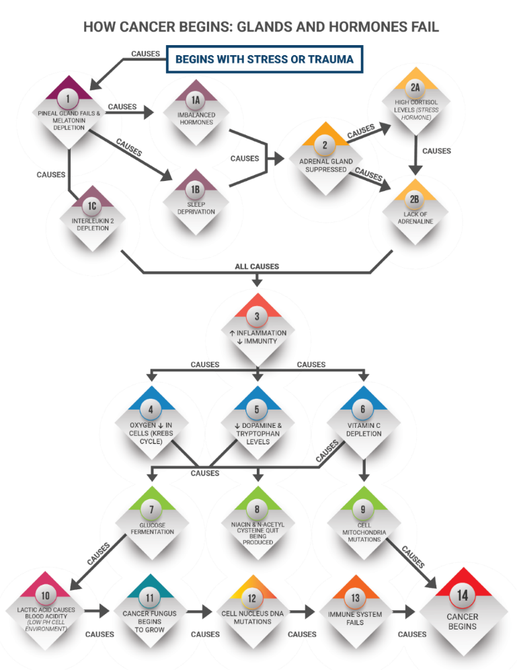
Fig. 1 Body stressors that cause abnormal cell growth [5]

Step 1: Replace melatonin – 10 to 40 milligrams (mg) at bedtime to replaces missing melatonin.

Step 1C: Beta glucans (mushrooms) as directed.

Step 2A: Adrenal gland suppression increases cortisol (high stress hormone). Decrease cortisol with the following:
- Sleep
- Exercise
- Decrease stressful thinking
- Relax
- Have fun
- Develop and maintain healthy relationships
- Spending time with pets
- Spirituality
- Eat a healthy diet
- Supplements as directed:
  - Omega-3 fatty acids
  - Ashwagandha
  - Phosphatidylserine
  - Ginkgo biloba leaf extract
  - Choline bitartrate
  - L-Theanine
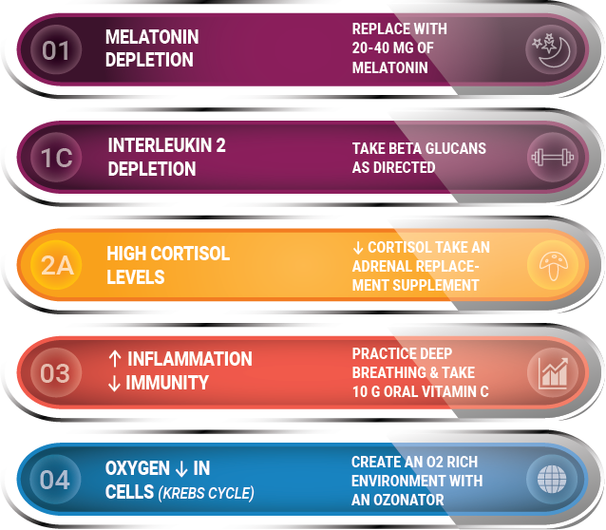

Fig. 2: Steps 1 to 4 Replacing body stressors to correct for wellness [5]

Step 2B: Adrenaline levels increased:
  - Diet:
    - Brightly colored vegetables
    - Lean white protein such as fish and chicken
    - Whole-grain and gluten-free carbohydrates
  - Sleep
  - Methylated B vitamins
  - Decrease inflammation
  - Supplements as directed:
- Vitamin D
- Vitamin C
- Selenium
- Magnesium
- Zinc
f. Hydration – 1/2 body weight in ounces of water plus add ounces of water for anything else drank
g. Adaptogenic herbs
- Licorice root
- Rehmannia

Step 3: Increased inflammation and decreased immunity causes Interleukin-1 production. Interleukin-1 is a performance-killing cytokine that can cause ill health and inflammation [6]. Beta glucans increase immunity.

Step 4: Cancer cannot grow in an O2-rich environment. Buy an oxygenator for water and drink oxygen rich water. Eat the Budwig breakfast to restore oxygenation to cells [7].

Step 5: Replace dopamine and tryptophan: wear information chips several hours a day to replace levels [8]. Order chips at www.akuryproducts.com or supplement orally.

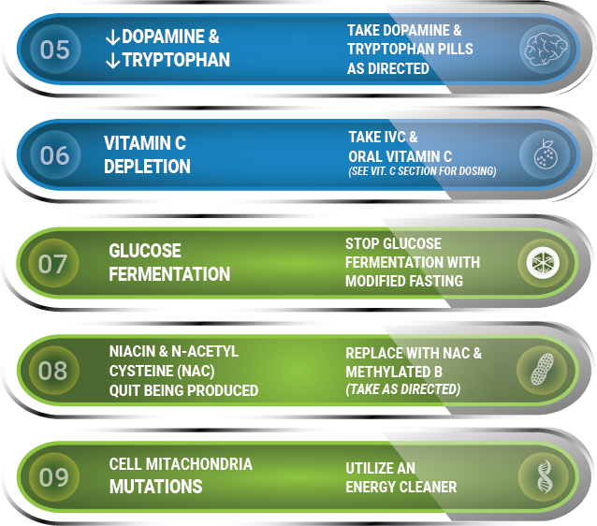

Fig. 3: Steps 5 to 9 Replacing body stressors to correct for wellness [5]

Step 6: Vitamin C – both IV and Oral. Use caution. Do not use with liver cancer. Oral vitamin C, 10 grams (consider crystalline Vitamin C) in three divided doses.

Step 7: Glucose fermentation must be stopped:
Eat cultured foods like yogurt, kefir, kombucha, sauerkraut, kimchi, pickles, sourdough bread, and probiotics, all without sugar.

Step 8: Lack of niacin (one of the B Vitamins) production can be supplemented with Methylated B vitamins and N-Acetyl Cysteine (NAC).

Step 9: Cell mitochondrial mutations are decreased as Energy Cleaners decrease deoxyribonucleic acid (DNA) mutations.

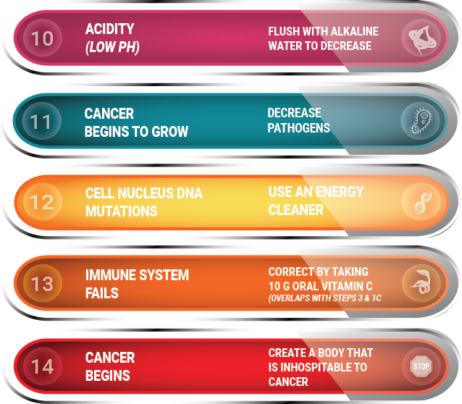
Fig. 4: Steps 10 to14, Replacing body stressors to correct for wellness [5]

Step 10: Cancer produces lactic acid. Lactic acid causes blood acidity to increase, decrease lactic acid (acidity) with alkaline water. Test with pH strips on both saliva and urine. The optimal urine pH is between 6.5-7.0 and the optimal saliva pH is between 6.8-7.4 [9]. Use baking soda to increase pH by stirring one teaspoon into three ounces of water then drink every two hours until pH tests in the right range. Use calcium lactate to decrease the pH and calcium hydroxide or calcium citrate to increase pH. Calcium gluconate to keep the pH the same [10].

Step 11: Cancer begins to grow – our bodies harbor pathogens [11]. Decrease pathogens by following a low sugar diet and utilizing the Bob Beck Protocol [11].

Step 12: Cell nucleus DNA mutations are decreased as the Energy Cleaner decreases DNA mutations.

Step 13: Immune system starts to fail. Deficiencies can be corrected with vitamin B6, Elderberry, Pelargonium, Olive Leaf Extract, N-Acetyl Cysteine, Astragalus, and Larch.

Step 14: Cancer cannot grow in a body inhospitable to cancer.

Restore Energy frequency to normal levels
Energy frequency must be raised to a healing frequency for the cells to respond and grow. Other studies show that negative thoughts lower our voltage or energy frequency on average 12 Hertz [12]. Positive thoughts raise our voltage or energy frequency on average 10 Hertz [12]. Prayer and meditation raise our energy frequency on average 15 Hertz [12].
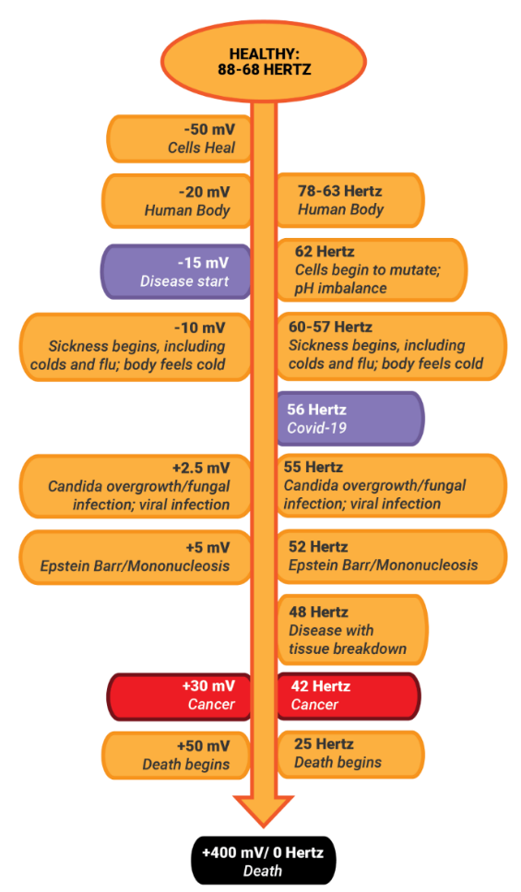

Fig. 5: Energy frequency chart [5]

Millivolts, Hertz, pH Levels, and Disease Process
To heal, the pH of the body has to be at 7.88 or slightly alkaline as cancer and advanced disease are acidic and cells heal in an alkaline environment [3]. The easiest and cheapest way to do this is with baking soda, one teaspoon stirred in three ounces of water.

Millivolts [3] | Hertz [12] | pH | Disease Process
-380 |  | 9.5 | Alkaline water
-80 |  | 8.0 | Cancer cells die/healthy cells live
-50 |  | 7.88 | Heal by making new cells
-45 | 80-88 | 7.79 | Genius brain frequency
-35 | 78 | 7.61 | Kids and athletes
-30 | 73 | 7.53 | Gains electrons
-25 | 68 | 7.44 | Adults, cancer cells become dormant
-20 | 62 | 7.35 | Cells begin to mutate, pH imbalance, chronic illness, pain
-15 | 61 | 7.26 | Tired, chronic oxygen deprivation, problems with fat processing
-10 | 60 | 7.18 | Receptive to sickness, including coronavirus and influenza, body feels cold, wakes up all internal pathogens, damages cells
-5 | 56.6 | 7.09 | Receptive to Covid-19
0 |  | 7.00 | Polarity changes
+2.5 | 55 | 6.56 | Candida overgrowth begins, fungal infections, and viral infections
+5 | 52 | 6.91 | Receptive to Epstein Barr/Mononucleosis
+10 | 48 | 6.83 | Receptive to obesity, loses electrons
+20 | 46 | 6.65 | Receptive to tissue breakdown
+25 | 44 | 6.56 | Receptive to injury
+30 | 42 | 6.48 | Receptive to cancer
 | 25 |  | Death begins
+400 | 0 | 0 | Death

Immune system, body stressors, and illnesses
One affected with cancer or advanced disease cannot hope to get well without an intact immune system that is functioning optimally. The immune system functions to fight bacteria, viruses, parasites, and fungi to allow the individual to get well. Chemotherapy can cause additional tumors. Therefore, so many of those released from chemotherapy are told that another tumor may occur. When the immune system fails, the allergies and other pathogens rise—an inverse principle. If the immune system rises, allergies decrease. An individual that wants to increase their immune system should supplement with large amounts of vitamin C, and beta glucans as directed.
The immune system optimally repairs itself with a diet of 80% fresh vegetables and juice, whole-grains, seeds, nuts, and a little fruit to help put the body into an alkaline state. A total of 20% can be from cooked food, including beans [2]. Live enzymes are found in fresh juice. These are often oxalic acid which are easily absorbed. This will usually get down to a cellular level within 15 minutes, and if your pH is 7.88, healthy cells will regrow [2].

Poisons we encounter every day activate tumor-promoting genes, ignite proinflammatory molecules, and exhaust detoxifying substances in the liver which can lead to cancer development [13]. Most people have survived with the base version of the genetic detoxification encoded in our DNA, which is not adequate to rid the body of toxins in the 21st century.

hyperthermia [14]
Hyperthermia is an immunological treatment where body tissue is exposed to fever range high temperatures to damage and kill cancer and advanced disease cells. An increase in body temperature is strongly correlated with a decrease in inflammation and survival from infection and disease. This was originally discovered by Dr. William Coley, and implemented by Dr. Ralf Kleef, of Budapest Hungary.

Emotions
Cancer is a disease of the mind, body, and spirit [2]. A proactive and positive spirit is alkalizing and helps lead to overall wellness. Emotions get buried inside of a person; anger, unforgiveness, and bitterness put the body into a stressful and acidic environment that stresses the body [2]. To get in touch with that part of our eternal selves, we must learn to have a loving and forgiving spirit internally to relax and enjoy life.
Many who have survived cancer did so by using traditional treatments as life-saving medical intervention and then began focusing on healing of body, mind, and spirit. They were able to focus more on the vital forces of nature through living food, sunlight, fresh air, clean water, meditation, yoga and spiritual reconnection.
The body can heal itself when all the underlying problems are corrected. In Figure 6, the different levels of emotion are listed in Hertz. When positive emotions are experienced, it floods the body with healing negative energy frequency boosting the body toward wellness.

TABLE I
ENERGY FREQUENCY, PH, AND DISEASE PROCESS

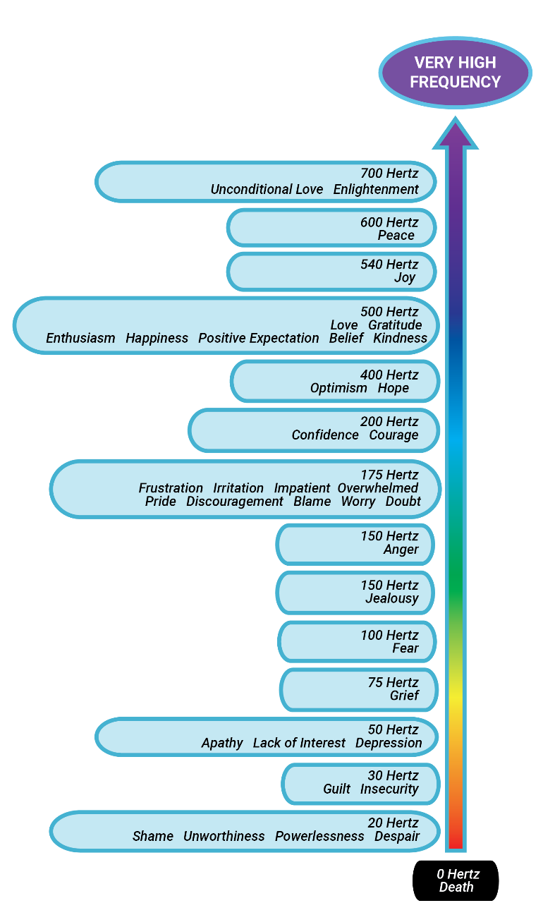
Fig. 6 Energy frequency of emotions [5]

Eleven Natural Recipes for cancer and advanced disease

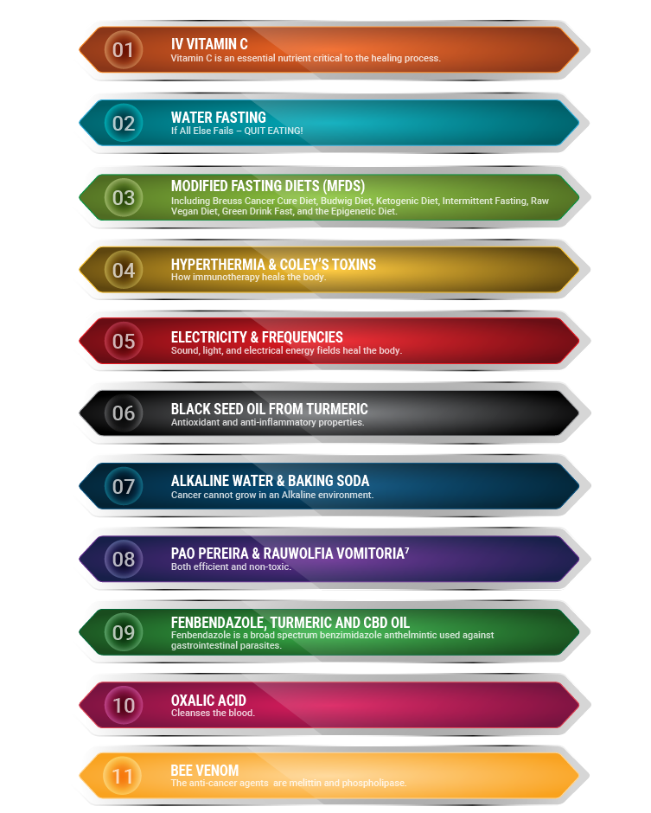

Fig. 7 Natural items that decrease body stressors to allow the immune system to function [5]

a. Vitamin C [5]
Vitamin C is critical for life extension in advanced cancer and quality of life. It is a natural chemotherapy that works because the vitamin C molecule looks like sugar to the cancer cell. People who have been diagnosed with cancer have lower levels of vitamin C, and a large number of them with hypovitaminosis, or less than 23 μmol of vitamin C per liter of blood, and others have a deficiency of less than 11 μmol of vitamin C per liter of blood. A lack of vitamin C appears to correspond to the level of advanced disease. Oral vitamin C is an antioxidant meaning that it kills or eliminates free radicals. Intravenous vitamin C is a prooxidant to achieve high levels of concentration of vitamin C.
b. Water Fasting [5]
Water fasting is exactly what the name is saying: eat nothing but drink clean water in an attempt to starve the cancer out of the body.
c. Modified Fasting Diets [5]
Modified fasting diets are diets in which specific items are eaten to simulate fasting. Some of these are the Bruess diet, the Budwig diet, the keto diet, intermittent fasting, the raw juice diet, the green juice diet, and the epigenetic diet.
d. Hyperthermia [5]
Hypothermia is an immunological treatment where the body tissue is exposed to high temperatures of fever range in order to damage and kill cells. An increase in body temperature is strongly correlated with a decrease in inflammation and survival from infection and cancer.
e. Electricity and Frequencies
The human body is comprised of electromagnetic transmissions and communication. The body sends and receives electromagnetic waves. The electromagnetic energy that lives in human tissue is very strong. Electromagnetic energy is measured in frequencies, which is the measurable rate between any two points [12]. By restoring a frequency to a normal level, the body is better able to heal.
f. Blackseed From Turmeric [5]
Blackseed oil has medicinal uses for diabetes, migraines, and cancer. It can be ingested or added to massage oils, shampoos, skin care products, and fragrances. High quality black seed oil is also suitable for use in cooking, baking, and beverages. This is known as a exclusive cancer treatment.
g. Alkaline and Hydrogen Water [5]
Alkaline water is water that has a high pH level over 7.3 that converts the body from acidic to alkaline. To maintain an alkaline body, increase the pH to a healing level of 7.88. Cancer cells produce lactic acid levels in the body, so the alkaline level balance is disrupted by the acid produced from the cancer cells. Lactic acid must be flushed out with alkaline water to allow the body to heal.
h. Pao Pereira and Rauwolfia Vomitoria [5]
Both Pao Pereira and Rauwolfia Vomitoria extracts inhibit metastasis. The treatments can identify a specific protein in a tumor’s early stages so that metastasis does not occur. It has been found that blood flow controls location and the onset of tumor growth which can stop secondary tumor growth by keeping cancer cells away from circulation.
i. Fenbendazole, Turmeric, and CBD Oil [5]
Fenbendazole only works as a cancer treatment when it is combined with turmeric and CBD. It is unknown why the combination of these three drugs produces this effect on cancer. About 60% of all people treated with fenbendazole, turmeric, and CBD oil are healed from cancer.
j. Oxalic Acid [5]
Oxalic acid is identified as a monitor of the blood system it is cellicidal, meaning that it kills cells viruses and bacteria. Oxalic acid cleanses the blood. It is often found in green vegetables. When the levels of oxalic acid in the blood are low, abnormal cell growth begins to grow. When oxalic acid is increased in the blood, abnormal cell growth is prevented from forming and tumors can not grow.
k. Bee Venom [5]
Venom from honeybees or bee venom (apitoxin) is effective in treatment of some immune related diseases and cancer. It has effectiveness in renal, lung, liver, prostate, bladder, breast and leukemia cancer. Scientists do not understand how it works to kill cancer cells but melittin, a component of bee venom, kills cells in under one hour by punching holes in their outer membrane.
Cancer is going to kill you for sure if it is advanced and untreated. Naturopathic remedies have few to no side effects. It would be better to try something and fail than to die because nothing was tried.

Conclusion
Chemotherapy is chemical medicine that functions as poison to fast dividing cells but inevitably also will hurt the immune system, decreasing its proper function. An intact immune system that is functioning optimally is needed to heal from cancer or advanced disease. The immune system fights pathogens including bacteria, viruses, parasites, and fungi to allow wellness. Cells regrow when all the nutrients and supplements are present for wellness, the pH is at 7.88, the voltage is -50mV, and the immune system is functioning properly [1]. God gave an immune system to the body to heal itself when all the underlying body stressors are corrected.

References
- Dr. R. G. Hamer, German New Medicine, “How unresolved emotional trauma causes cancer (research)”, unpublished.
- John Hopkins University, “Cancer update from johns hopkins (research)”, unpublished.
- Dr. J. Tennant, Healing is Voltage Cancer’s On/Off Switches: Polarity (book). San Bernardino, CA: CreateSpace Independent Publishing Platform, 2015, pp. 26-28.
- American Cancer Society, “Cancer Treatment and Survivorship Facts & Figures 2019-2021 (research)”, 2019, pp. 24-25.
- D. Wright, Turning Months Into Years A QuickStart Guide: How to Decrease Stressors That Lead to Cancer and Advanced Diseases (book), 2021, pp. 21, 26-27, 35, and 61.
- N. Kaneko, M. Kurata, T. Yamamoto, S. Morikawa, and J. Masumoto, “The role of interleukin-1 in general pathology (article)”, 2019.
- J. Budwig, The Oil Protein Diet Cookbook (book), 1994.
- “Chips to optimize, promote, harmonize or regulate mental states (article)”, n.d., unpublished.
- P. Powers, “How healthy are you? measuring pH (article)”, 2017, unpublished.
- Trinity School of Natural Health, Analyzing pH (book), 2015, pp. 49.
- R. Beck, “The beck protocol a first aid kit of the future (handbook)”, 2015.
- D. G. Young, “Human electrical frequencies and fields (article)”, 1999.
- “Black cumin seed oil targets cancer (article)”, 2020, unpublished.
- R. Kleef, S. Kekic, and N. Ludwig, “Successful treatment of advanced ovarian cancer with thermochemotherapy and adjuvant immune therapy (article)”, 2012.

Diana Wright (ND, MBA, BSN) was born in Shreveport, Louisiana on April 10th, 1957. Wright attended Northwestern State University in Natchitoches, Louisiana, graduating with a Bachelor of Science in nursing in 1981. In 1982, Wright passed the Louisiana State Board of Nursing, becoming a registered nurse. Wright graduated from Centenary College of Louisiana in Shreveport, Louisiana in May 1991 with a Master of Business Administration. In 2018, Wright obtained her Doctor of Naturopathy at Trinity School of Natural Health in Warsaw, Indiana.
She worked as the charge registered nurse in the ICU, Supervisor, Assistant Director of Nurses (ADON), Director of Nurses (DON), the Quality Manager at the VA Medical Center in Shreveport, Louisiana, and eventually founded The Right Solutions travel nursing agency in 1996. At The Right Solutions, she served as Owner and President/Chief Executive Officer. Currently, she is founder and Doctor of Naturopathy at Divine Health in Siloam Springs, Arkansas. She has authored three books thus far: The Unbelievable Plight of Mrs. Wright (Siloam Springs, Arkansas, self-published, 2019), Turning Months into Years: A QuickStart Guide (Siloam Springs, Arkansas, self-published, 2021), and Turning Months into Years Workbook (Siloam Springs, Arkansas, self-published, 2021). She is Executive Producer of the internationally award-winning film The Unbelievable Plight of Mrs. Wright, filmed by Grow Vision Studios in 2019. Current research interests are medical freedom, cancer, advanced diseases, neuropathy, hypothyroidism, and energy frequency. She is in the process of publishing Rebuilding the Body After Chemo, Radiation, and Surgery, Management Done Wright, Life After Gastric Bypass Surgery, and The Story of Jennifer.
Ms. Wright is currently a member of the Republican Party of Arkansas, Board Member of the Arkansas Workforce Development Board, Board Certified member of the American Association of Drugless Practitioners (AADP), and holds a MSA certification in Qest Technician Training. She is previously a board member of The Joint Commission for six years, Advanced Nurse Executive for the American Nurses Credentialing Center (ANCC), Sigma Theta Tau International Honor Society of Nursing at Northwestern State University in 1991, certified as a professional in healthcare quality from the Healthcare Quality Certification Board in 1992, and member of the Nursing Honor Society at University of Arkansas in 1996. Wright won the National Leadership Award in 2003 as Honorary Chairman on the National Republican Congressional Committee, named Arkansas Businessman of the Year in 2004, Arkansas Business Executive of the Year in 2008, recognized as Arkansas Best Nurse of the Year in 2015, named one of the Global Power 150 Women in Staffing by Staffing Industry Analysts in 2019, and won the 2021 Top 50 Healthcare Companies Award. The internationally acclaimed documentary based on her life, The Unbelievable Plight of Mrs. Wright, has won over 60 awards worldwide.

